|  |  |  |  |  |  |  |  |  |  |  |  |  |  |  |
| --- | --- | --- | --- | --- | --- | --- | --- | --- | --- | --- | --- | --- | --- | --- |
|  | LCRNS SRD RQMT. Source | RQMT Subject | Increment A | | | Increment B | | | | Increment C | | | | |
| **NASA RQMT** | Table 3-3 | Service Type | Ka-Band | S-Band | AFS | Ka-Band | S-Band | AFS | | Ka-Band | | S-Band | LANS | |
| Table 3-3 | Number of Simultaneous Services | 1 | 1 | 1 | 1 | 1 | 2 | 3 | 2 | | 2 | 4 | |
| Table 3-3 | Forward / Return | R | F/R | F | F/R | F/R | F | F | F/R | | F/R | F | |
| Table 3-3 | Service Volume | SV1  (-80 degrees latitude, surface to 125km altitude) | | | SV1  (-80 degrees latitude,  surface to 125km altitude) | | | | SV2  (-75 degrees latitude, surface to 200km) | | | | |
| Table 3-3 | % Daily Coverage of Service Volume | 70% | | | 75% | 90% | 70% | 40% | 75% | 90% | | | 40% |
| **IM MEETS** | Constellation Configuration | | Khon2 (ELFO) | | | Khon2-4 (ELFO) | | | | Khon2-6 ELFO | | | | |
| Number of simultaneous services available to Service Volume | | 2 F/R | 2 F/R | 1 | 6 F/R | 6 F/R | 3 | 3 | 10 F/R | | 10 F/R | | 5 |
| Coverage (% of day the required number of service links have simultaneous coverage to a single point in the service volume) | | >80% | >80% | >80% | 100% | 100% | >90% | >80% | 100% | | 100% | | >48%  (4 LANS w/ GDOP  < 6) |
| Table 2.2.3-1. SERVICE COVERAGE AND CAPABILITY AGAINST LCRNS SRD TABLE 3-3 REQUIREMENT | | | | | | | | | | | | | | |

A simplified representation of the relay satellite orbits is shown in Volume II §2.1.3. The full set of six element orbital parameters by increment epoch are presented here for Increment A (**Table 2.2.3-2**), B (**Table 2.2.3-3**), and C (**Table 2.2.3-4**) respectively. These are the parameters used to calculate the service coverage and visibility of simultaneous service links that meet the requirements identified in LCRNS SRD **Table 3-3**. Orbit parameters are provided in Cartesian form in the Moon Centered J2000 frame. Each set of parameters is referenced to the start of IM’s operational capability by increment, and this date is used as the reference epoch for each set of orbit parameters.

|  |  |  |  |
| --- | --- | --- | --- |
| Satellite | Launch Date | Operational Date | Increment A  Orbital Parameters  (Cartesian in km, km/s)  (Moon Centered J2000 Frame)  (Start of Epoch: 3/1/2025 00:00h UTC) |
|  |  |  |  |
| Khon-2 | 4/2025 | 3/2026 | Rx: 1.092301377920434E+03 km  Ry: 1.315350335796247E+02 km  Rz: -1.994563379260933E+04 km  Vx: 2.181184169309954E-01 km/s  Vy: 1.747388035560749E-02 km/s  Vz: -2.927134922217063E-02 km/s |
| Table 2.2.3-2. LDN RELAY SATELLITE CONSTELLATION FOR INCREMENT A CAPABILITY | | | |

|  |  |  |  |
| --- | --- | --- | --- |
| Satellite | Launch Date | Operational Date | Increment B  Orbital Parameters  (Cartesian in km, km/s)  (Moon Centered J2000 Frame)  (Start of Epoch: 3/1/2026 00:00h UTC) |
|  |  |  |  |
| Khon-2 | 4/2025 | 3/2026 | Rx: 1.092301377920434E+03 km  Ry: 1.315350335796247E+02 km  Rz: -1.994563379260933E+04 km  Vx: 2.181184169309954E-01 km/s  Vy: 1.747388035560749E-02 km/s  Vz: -2.927134922217063E-02 km/s |
| Khon-3 |  | 3/2027 | Rx: -4.878848584906256E+03 km  Ry: 9.317685336793074E+02 km  Rz: -1.614623521308764E+03 km  Vx: 5.366435178375880E-01 km/s  Vy: -8.146231442604626E-01 km/s  Vz: 6.961340561402040E-01 km/s |
| Khon-4 |  | 3/2027 | Rx: 4.995677196204575E+03 km  Ry: 5.103319697670522E+02 km  Rz: -1.069562357174495E+03 km  Vx: -6.670371948511168E-01 km/s  Vy: -7.226508288310302E-02 km/s  Vz: 1.009135881680717E+00 km/s |
| Table 2.2.3-3. LDN RELAY SATELLITE CONSTELLATION FOR INCREMENT B CAPABILITY | | | |

|  |  |  |  |
| --- | --- | --- | --- |
| Satellite | Launch Date | Operational Date | Increment C  Orbital Parameters  (Cartesian in km, km/s)  (Moon Centered J2000 Frame)  (Start of Epoch: 3/1/2027 00:00h UTC) |
|  |  |  |  |
| Khon-2 | 4/2025 | 3/2026 | Rx: 1.092301377920434E+03 km  Ry: 1.315350335796247E+02 km  Rz: -1.994563379260933E+04 km  Vx: 2.181184169309954E-01 km/s  Vy: 1.747388035560749E-02 km/s  Vz: -2.927134922217063E |
| Khon-3 |  | 3/2027 | Rx: -4.878848584906256E+03 km  Ry: 9.317685336793074E+02 km  Rz: -1.614623521308764E+03 km  Vx: 5.366435178375880E-01 km/s  Vy: -8.146231442604626E-01 km/s  Vz: 6.961340561402040E-01 km/s |
| Khon-4 |  | 3/2027 | Rx: 4.995677196204575E+03 km  Ry: 5.103319697670522E+02 km  Rz: -1.069562357174495E+03 km  Vx: -6.670371948511168E-01 km/s  Vy: -7.226508288310302E-02 km/s  Vz: 1.009135881680717E+00 km/s |
| Khon-5 |  | 3/2028 | Rx: -9.531908936264546E+03 km  Ry: 7.372113100283372E+03 km  Rz: -1.444437336245974E+04 km  Vx: 2.302750361026784E-03 km/s  Vy: -2.233486335779166E-01 km/s  Vz: -1.669856345185168E-01 km/s |
| Khon-6 |  | 3/2028 | Rx: 1.136935266798489E+04 km  Ry: 7.028614821202296E+03 km  Rz: -1.322050978241846E+04 km  Vx: 3.388062360981547E-03 km/s  Vy: 2.652729826546564E-01 km/s  Vz: 8.687221365031624E-02 km/s |
| Table 2.2.3-4 LDN RELAY SATELLITE CONSTELLATION FOR INCREMENT C CAPABILITY | | | |

2.2.4 LANS GDOP Perormance Analysis

LANS GDOP Performance Analysis is shown in Volume II §2.9.

The IM team has continued to refine the Khon network orbital geometry to optimize operational metrics for PNT coverage across SV2 while minimizing station-keeping costs for the constellation. The constellation shown in **Figure 2.2.4-1** shows the configuration of the proposed system across IOC phases.

|  |  |  |
| --- | --- | --- |
| **IOC-A: Khon 2**  **1 link, SV1 = 90%**   | **IOC-B: Khon 2-4**  **3 links, SV1 = 86.5%**   | **IOC-C: Khon 2-6**  **4 links, GDOP < 6, SV2 = 25%-45%**   |

Figure 2.2.4-1. KHON-2 THRU KHON-6 ELLIPTICAL FROZEN ORBIT CONSTELLATION

The constellation consists of five fully LCRNS compliant PNT satellites in four planes of highly elliptical frozen orbits (ELFO), Khon‐2 and Khon‐4 are grouped in one ELFO plane, Khon-3, Khon-5, and Khon-6 are in separate ELFO planes that are arranged to provide reliable coverage and geometric diversity during the lunar month. The constellation configuration has been refined since the initial proposal to both optimize the GDOP coverage and eliminate gaps across the service volume for each Earth day during the lunar month. The periods of the highly elliptical frozen orbits are 29 hours. These satellites spend 2.5 hours out of view of the south pole per 29‐hour orbit. This gives 81% of the orbit where the ELFO satellites are above the horizon. We also note that all these coverage percentages increase at the top of the 200 km high zone bounding the service volumes. **Table 2.2.3-4** provides the full Cartesian state for each satellite in the constellation in a Moon centered J2000 inertial reference frame for a common epoch at Feb 1, 2027 0:00 UTC (ET = 854712069.18 TDB).

A simulation of the Khon 2-6 ELFO constellation trajectory was conducted for a period starting from the initial reference epoch given in Table 1. The satellite orbits are model with N-body gravity for the Sun, Earth, and using the GRAIL GRGM1200B 100x100 degree and order gravity model for the Moon. **Figure 2.2.4-2** shows the orbit geometry over a 1-year period from the initial reference epoch, demonstrating that the orbits are inherently stable and require minimal station-keeping to remain in these respective orbits during the service interval.

|  |  |
| --- | --- |
|  |  |

Figure 2.2.4-2. KHON-2 THRU KHON-6 ELLIPTICAL FROZEN ORBIT CONSTELLATION

1-YEAR PROPAGATION

Numerous combinations of ELFO geometries we considered, using two, three, and four separate EFLO orbit planes, as well as adjusting the semi-major axis, eccentricity, inclination, and phasing of the individual orbits relative to one another. The current baseline maintains a common semi-major axis and thus orbit period between all satellites in the constellation. Two distinct eccentricities are used with Khon-1 thru Khon-4 in ELFO-1 and ELFO-2 using an orbital eccentricity of approximately 0.8, while the Khon-5 and Khon-6 satellites use an orbital eccentricity of approximately 0.7, located in ELFO-3 and ELFO-4 respectively with. An inherent property of the ELFO family results in a relationship between eccentricity and inclination, . Utilizing this property, differences in eccentricity also result in differences in inclination which helps to increase geometric diversity between the different ELFO orbits.

Variations of these baseline ELFO’s are still being considered where the eccentricity and apolune can be adjusted to within +/-10% of their current default values, while still maintaining the stability and overall geometry within their respective ELFO orbit planes. These small adjustments to the relative phasing and orbit periods for individual assets in the constellation can have somewhat substantial impacts to the resultant GDOP coverage within the Lunar South Pole (LSP) service volume at a specific time. This is considered to be an advantage of the phased ELFO configuration as there is an enormous space of adjustment that is available for very minor delta-V costs. Adjustments for single or multiple satellites in the Khon network can be made to optimize GDOP for a specific time in the future, while operating in and around the stable ELFO configuration.

**Figure 2.2.4-3** shows that for a majority of the time that all 5 satellites are simultaneously in view within the LSP coverage zone. There are times that the coverage briefly drops down to 2 or 3 where the GDOP increases, but this ensures consistent coverage for all LSP sites for every Earth day. The average GDOP for a Lunar South Pole user is 3.9 over the lunar month with this configuration.

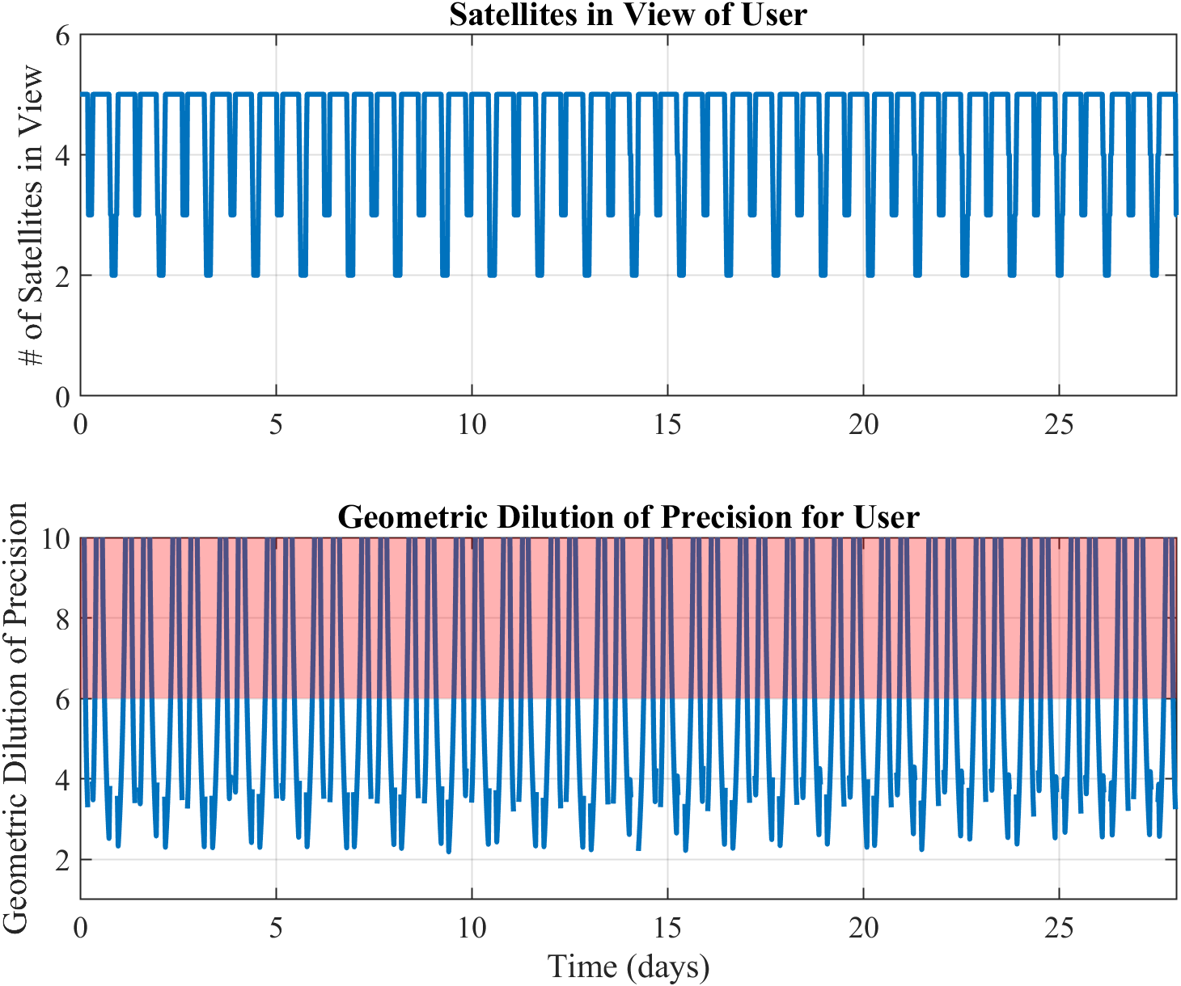

Figure 2.2.4-3. NUMBER OF SATELLITES WITHIN LINE OF SITE AND GDOP COVERAGE OVER A LUNAR MONTH FOR THE 5-SATELLITE ELFO CONFIGURATION

The baseline Khon network ELFO geometry is optimized to minimize coverage gaps and to ensure coverage at the least covered regions in SV2 at all times. GDOP coverage in this configuration (shown in **Figure 2.2.4-4**) was determined to range from 25%-45% for the worst-case Earth day within the lunar month, for any fixed location within the service volume. In order to meet the 40% coverage requirements specified in LCRNS.3.0130 for all points within SV2, the IM system includes capability to adjust the phase of each PNT satellite to provide coverage any specific site within SV2 at a specified time. Anywhere that NASA operations require 40% coverage with GDOP<6 and/or multiple 5-hour EVA windows with GDOP<6 on a specific Earth day, capability does exist to adjust the phasing of the satellites in their respective ELFO’s to ensure that coverage and performance can be provided when required during the IOC-C phase of operations.

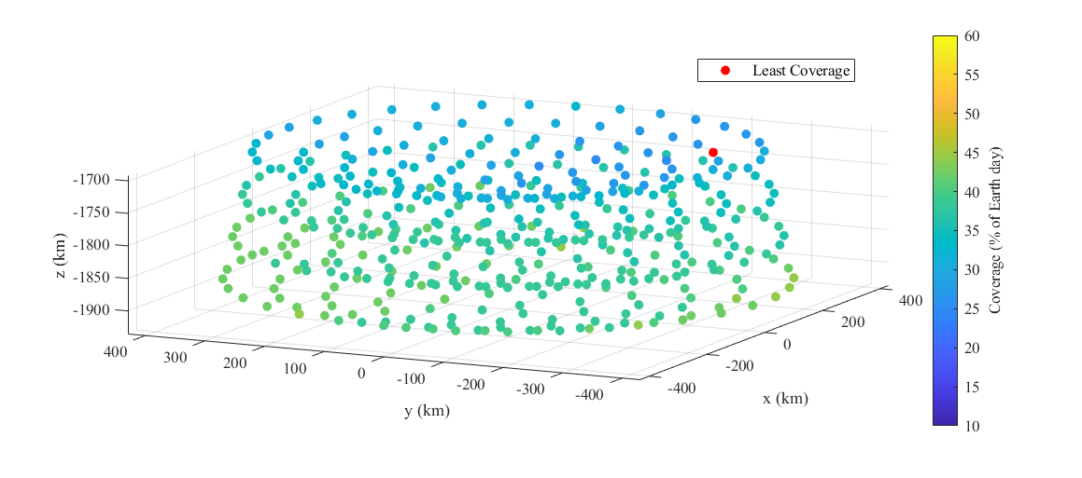

Figure 2.2.4-4. GDOP COVERAGE FOR THE WORST-CASE EARTH DAY WITHIN THE LUNAR MONTH FOR THE 5-SATELLITE ELFO CONFIGURATION

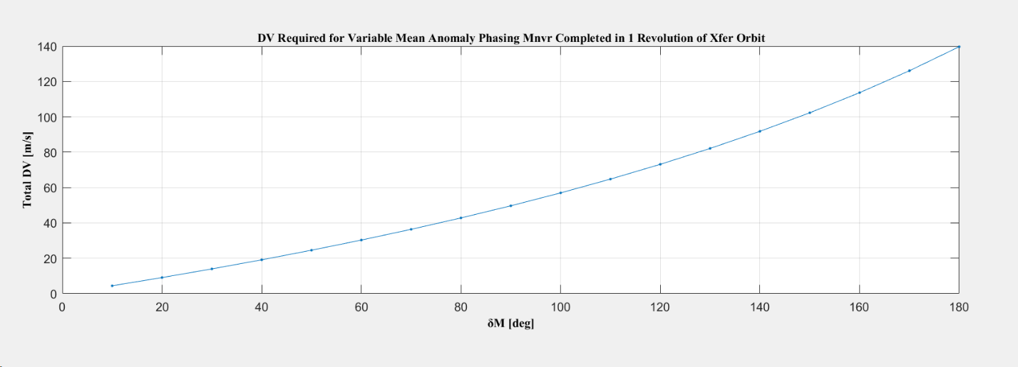

Figure 2.2.4-5. DELTA-V REQUIRED TO ADJUST ELFO MEAN ANOMALY

IN ONE ORBIT REVOLUTION



Figure 2.2.4-6. EVA OPPORTUNITIES OVER A 24-HOUR INTERVAL WITHIN THE LUNAR MONTH FOR THE 5-SATELLITE ELFO CONFIGURATION

**Figure 2.2.4-5** shows an assessment of the operational delta-V needed to adjust the mean anomaly of an asset within a fixed time interval within their respective ELFO. Assuming the orbit period is adjusted at perilune, we can achieve a 90-degree mean anomaly adjustment with ~20 m/s in 48 hours, or ~50 m/s in 24 hours. Expecting that a minor mean anomaly adjustment (<< 90-degrees) should be sufficient to augment the configuration for ideal geometric coverage, this adjustment should be manageable with a 5-10 m/s correction -depending on the time available to make the adjustment. This also improves coverage for the PNT services requirement for at least two lunar surface EVAs lasting at least 4 hours nominally plus 1 hour contingency.

The ELFO arrangement is effective at minimizing gaps across the worst-case coverage day, and also can be easily optimized to provide two opportunities for 5-hour EVA’s as shown in **Figure 2.2.4-6**. The highlighted green blocks are 0.2 days (5 hours) in duration to indicate intervals during the day when GDOP<6 coverage for the LCRNS.3.0240 EVA surface initial Operations Duration requirement is best satisfied. The yellow highlighted block indicates when a 4-hour window is available, but the GDOP increases above 6 during the contingency hour. In this example, the GDOP coverage does briefly increase above six, but PNT coverage from 4-5 satellites is continuous and the average GDOP of approximately 4.2 is supported during the interval. GDOP coverage plots for every 24-hour interval across the lunar month for the baseline Khon Network configuration are presented in Appendix D.

2.2.5 Launch Strategy and Plan to Reach Operational Orbit

Each Khon satellite is sized to meet requirements for launch on an ESPA Grande adapter ring and launches in concert with one of IM’s Nova-C landers on an IM-dedicated SpaceX Falcon 9 launch vehicle (Volume II Figure 2.8.1-1). The launch schedule is shown in Volume II Table 2.1.3-1. Each Khon satellite bus is equipped with a low thrust, high efficiency electric propulsion system and a higher thrust chemical propulsion system for orbit insertion and station keeping maneuvers. Together the two propulsion systems enable the Khon vehicles to reach their destination orbits as rideshare vehicles while also using a relatively small amount of delta-v. The translunar trajectory is designed primarily for the lander's mission, and the Khon vehicle will use its propulsion to modify its trajectory to enable a lunar flyby which will propel it into superlunar space. This lunar flyby enables a long-duration (90-120 days) indirect transfer to the destination orbit. The indirect transfer allows for two critical components to significantly affect the trajectory: the vehicle's high-efficiency (but low thrust) electrical propulsion system and the solar gravity perturbation. Both of these factors play a large role in modifying the trajectory over a long period of time and are used in concert with high-fidelity trajectory optimization tools to craft a minimum-fuel transfer orbit for the Khon vehicle. IM commissions and readies for operations the communication and PNT assets on the Khon vehicles during this transfer so that they are operational on arrival to the destination orbit.

P1313#yIS1

Figure 2.2.5-1. KHON-1 AND NOVA-C TRAJECTORIES (VISUALIZED IN THE EARTH-MOON TWO-BODY ROTATING FRAME)

The Khon1 trajectory design presented here is representative of the successive Khon transfer trajectories. Khon1 will be launched as a rideshare on the IM-2 Nova-C mission later this year on 18 November 2023. It will arrive in its destination elliptical lunar frozen orbit (ELFO) 114 days later on 11 March 2024. Its transfer trajectory is comprised of three distinct portions: transit to a powered lunar flyby, indirect transfer in superlunar space, and a series of final coasts and maneuvers once returned to the lunar sphere of influence to enter its final orbit. During its almost 7-day long transit to a powered lunar flyby, Khon1 will use its electrical propulsion system to set up the desired powered flyby performed with the chemical engine. This portion of the trajectory is shown in **Figure 2.2.5-1**, visualized in the Earth-Moon two body rotating frame with the corresponding Nova-C trajectory shown for reference.

After the powered flyby, Khon1 will be propelled into superlunar (heliocentric) space. This portion of the trajectory is composed of both ballistic coast arcs and low thrust arcs and will take the vehicle to a maximum distance of 1.2 million km from the Earth. Approximately 90 days after launch, Khon1 will re-enter the lunar sphere of influence after its superlunar maneuvering. The superlunar portion of the Khon1 trajectory is shown in **Figure 2.2.5-2**, visualized in the Sun-Earth two body rotating frame. Note that the purple arcs with gold direction vectors represent low thrust operations, the red direction vectors represent chemical propulsion operations, and the simple yellow arcs without direction vectors represent coasting flight.

P1317#yIS1

Figure 2.2.5-2. SUPERLUNAR PORTION OF KHON-1 TRAJECTORY (VISUALIZED IN THE SUN-EARTH TWO BODY ROTATING FRAME)

Khon1 will begin the final portion of the journey to its ELFO destination once it re-enters the lunar sphere of influence. This stage of flight is characterized by coasting along the manifold of a butterfly orbit for nearly 20 days which results in a close flyby of the Moon at a perilune altitude of 1500 km. At this perilune, Khon1 will initiate the first of a series of 3 lunar orbit insertion (LOI) maneuvers which will place the vehicle in the destination ELFO. LOI is broken into the 3 distinct maneuvers to optimize the delta-v capability of the chemical engine, allow for contingency operations in the case of an off-nominal burn, and provide time for orbit determination (OD) to enable precise orbit insertion. This portion of the Khon1 trajectory is shown below in a J2000-Moon frame. The first image (**Figure 2.2.5-3**) shows the coast along the manifold and LOI, while the second image (**Figure 2.2.5-4**) focuses on LOI operations. Note that both the yellow and green arcs indicate coasting flight, with the green lines indicating coasting during LOI operations. The maroon trajectory indicates the final orbit.

P1322#yIS1

Figure 2.2.5-3 KHON-1 LUNAR CAPTURE AND MANIFOLD COAST (SHOWN IN THE J2000-MOON FRAME)

P1326#yIS1

Figure 2.2.5-4. KHON-1 LOI AND ENTRY TO MISSION ORBIT (SHOWN IN THE J2000-MOON FRAME)

While the details of the above trajectory are associated with Khon-1, the general conops and design methodology are applicable to Khon2 through Khon6. IM has conducted multiple successful trajectory design efforts to-date for delivering a rideshare vehicle with limited self-propulsion into a variety of cislunar destinations (EML1, EML2, ELFO, LLO, etc.). This experience and comfortability with low energy trajectory design is a unique facet of IM that enables rapid deployment of cislunar resources through rideshares.

It is significant to note one additional advantage of IM’s trajectory approach. The Khon satellite only transits the Van Allen radiation belts a single time during its high energy trans-lunar period. Unlike more traditional “phasing loop” trajectories in which the spacecraft gradually raises its orbit between Earth and the Moon making repeated passes through the Van Allen belts, our trajectories for the Khon satellites quickly transit the radiation environment and only do this a single time. This greatly reduces the amount of radiation exposure for the mission.

The total Delta-V Budget for a typical Khon-1 vs. Khon-2 mission is given in **Table 2.2.5-1** below. Since the PNT satellites are required to insert into a very specific ELFO slot which may or may not be easily accessible for the rideshare launch date, an additional 200 m/s is allocated for the lunar transfer for these missions. It is expected that 5-10 m/s per year of station keeping delta-V will be required to maintain the ELFO orbits, so 50 m/s is allocated for this purpose. An additional 90 m/s is allocated for ELFO phasing support allowing for multiple adjustments to be made during the service interval to ensure peak coverage is available during key NASA operational events. Finally, 65 m/s is reserved for end of life to ensure capability is preserved to safely eject the Khon spacecraft from the Earth-Moon system for final disposal.

|  |  |  |
| --- | --- | --- |
|  | Khon-1 | Khon-2 thru Khon-6 |
| Lunar Transfer | 450 | 650 |
| GNC Dispersions | 30 | 45 |
| Station Keeping | 20 | 50 |
| Phasing | 0 | 90 |
| Disposal | 65 | 65 |
| Total | 565 | 900 |

Table 2.2.5-1. KHON ELFO TOTAL DELTA-V BUDGET

An example of the IM academic and technical rigor deployed in rideshare trajectory design is found in the publication "Trajectory Design for a Secondary Payload Within a Complex Gravitational Environment: The Khon-1 Spacecraft" by Hoffman, et al.

It is significant to note one additional advantage of IM’s trajectory approach. The Khon satellite only transits the Van Allen radiation belts a single time during its high energy trans-lunar period. Unlike more traditional “phasing loop” trajectories in which the spacecraft gradually raises its orbit between Earth and the Moon making repeated passes through the Van Allen belts, our trajectories for the Khon satellites quickly transit the radiation environment and only do this a single time. This greatly reduces the amount of radiation exposure for the mission.

2.2.6 Earth Ground Stations



















































As described in our proposal Volume II Section 2.1.4. Details associated with the DTE ground stations is provided in **Table 2.2.6-1**.